You’re designing a decision-support tool for snack selection. Each snack has a health score (1 = healthiest, 10 = least healthy). The binary tree helps users explore snack choices based on their preferences.
Objectives
- Implement a binary tree in C++ using snack data.
- Practice recursive insertion and traversal.
- Model real-world decision logic using tree structures.
- Search the binary tree recursively by snack name.

Tasks – Use Starter Code
- Build the Tree Insert the following snacks (snack name, health score, calories):
"Granola Bar", 5, 180
"Apple", 2, 95
"Chocolate Cake", 9, 350
"Carrot Sticks", 1, 50
"Potato Chips", 7, 250
"Yogurt", 4, 120
"Cheese Sticks", 14, 200

You may place the data into a file and read the initial values in to build this tree or you may assign the initial value within your code.

The tree will be built on health score. If the health score is found in a node already in the tree, then use calories as a secondary measure to place the node in the tree. The insertion function will use recursion to properly place the new node into the tree.
- Traverse the Tree Write an in-order traversal to print snacks from healthiest to least healthy. The tree is in order by health score. This recursive display of each node will be by health score, lowest to highest.
- Prompt the user: Prompt the user for a snack name and when found, display snack name, health score and calories. Display a message if the snack name is not in the tree. Repeatedly prompt the user for snack name, use a sentinel value to end.

Notice the tree is displayed in order of health score.
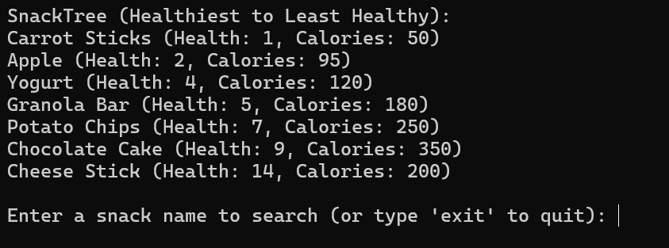

You may use a class or structure. Below is an example of a structure. Note nodes have two pointers known as a left and right. Node to the left contain health scores that are less than the current node. Nodes to the right contain health scores that are greater than the current node.
struct SnackNode {
string name;
int healthScore;
int calories;
SnackNode* left;
SnackNode* right;

SnackNode(string n, int hs, int cal)
: name(n), healthScore(hs), calories(cal), left(nullptr), right(nullptr) {
}
};

